Introduction to Scaling Agile Frameworks
As organizations grow, a single Scrum team is often not enough to build and deliver complex products. Multiple teams must collaborate, align their goals, and work toward a shared roadmap. However, without structure, large Agile setups suffer from duplicated work, inconsistent quality, and coordination failures. Scaling Agile Frameworks provide a systematic way for many teams to stay synchronized, deliver value frequently, and maintain the benefits of Agile speed, transparency, and adaptability even at enterprise scale.
As organizations grow, a single Scrum team becomes insufficient to handle large, complex products. Multiple teams must collaborate, remain aligned, and deliver integrated increments. To solve challenges like:
- Dependencies
- Duplication of work
- Cross-team misalignment
- Large-scale coordination
various Agile Scaling Frameworks were developed. These frameworks extend Agile principles beyond one team and provide structure for large programs with 50–300+ people.

1. LEAN

Lean Overview
- Lean is a mindset, not a framework.
- Influences most major Scaling Agile frameworks (SAFe, Disciplined Agile, LeSS).
- Originated from the Toyota Production System.

Core Focus
- Maximize customer value.
- Eliminate waste in processes.

Key Lean Concepts
- 7 Wastes : Overproduction, waiting, over processing, inventory, motion, transport, defects.
- Value Stream Mapping: Visualizes flow to detect inefficiencies.
- Just-in-Time (JIT): Work only when needed.
- Kaizen: Continuous incremental improvement.
- Built-in Quality: Quality is embedded from the start.
- Respect for People: Empower teams, encourage ownership.

2. SAFe (Scaled Agile Framework)

SAFe Overview
- A framework for applying Agile at scale.
- Structures work across team → program → portfolio levels.
- Combines Lean, Agile, and DevOps.

Core Concepts
- Agile Release Train (ART)
  - A long-lived team of 5–12 Agile teams delivering value.
- PI Planning
  - Teams align every 8–12 weeks.
- Lean Portfolio Management (LPM)
  - Connects strategy, budgets, execution.

SAFe Configurations
- Essential SAFe – ART + core teams
- Large Solution SAFe – Multiple ARTs
- Portfolio SAFe – Strategic alignment + Lean budgeting
- Full SAFe – All layers combined

Key Roles
- RTE (Release Train Engineer) – Chief Scrum Master for ART
- Product Management – Owns Program Backlog
- Solution Architect – Ensures technical alignment

Core Values
Alignment • Built-in Quality • Transparency • Execution

3. SCRUM OF SCRUMS

Overview
- Coordinates multiple Scrum teams working on one product.
- Manage cross-team dependencies and alignment.

How It Works
- Each team continues normal Scrum practices.
- Representatives (often Scrum Masters) meet regularly.
- Meetings address shared risks, blockers, and dependencies.
- Facilitator guides collaboration (often a Chief Scrum Master).

Key Points
- Adds minimal coordination without heavy processes.
- Maintains Scrum’s simplicity.
- Suitable for small-to-mid scaling without full SAFe.
- SCRUM@SCALE

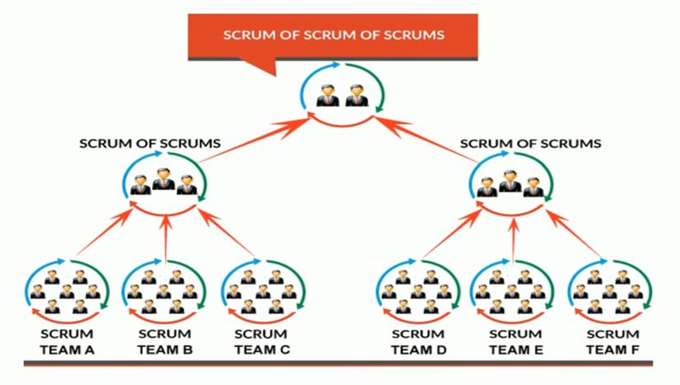

Overview
- Designed by Jeff Sutherland.
- Scales Scrum organically without heavy governance.
- Solves:
  - Gaps
  - Duplication
  - Dependencies
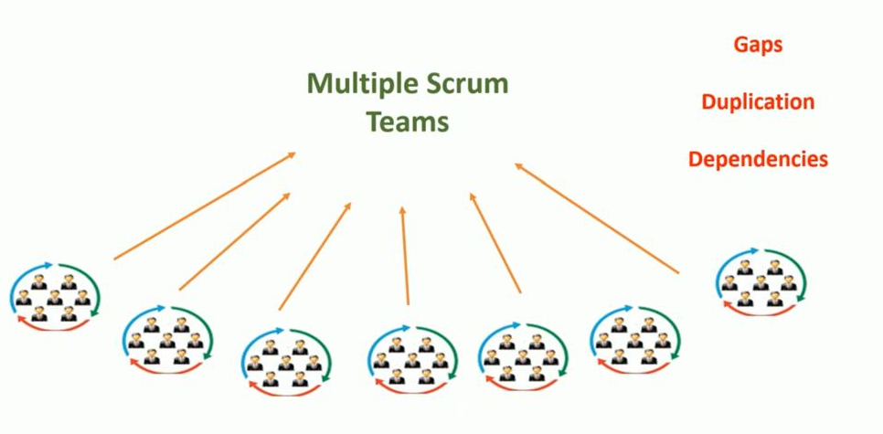

Key Components
- Scrum of Scrums (SoS)
- Scrum of Scrum of Scrums (SoSoS)
- Executive Action Team (EAT) – removes enterprise blockers
- Executive MetaScrum (EMS) – aligns business priorities
- Multiple Scrum teams at bottom.
- Connected into Scrum of Scrums.
- Higher coordination layer: Scrum of Scrum of Scrums.

When to Use
- Mid-to-large organizations wanting lightweight scaling.
- No extra roles added artificially.

- NEXUS

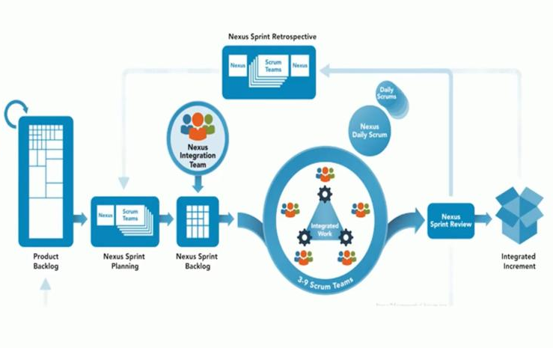
A minimal yet structured approach for 3–9 Scrum teams working on one integrated product.

Key Concepts
- One Product Backlog
- Nexus Integration Team (NIT)
  - Identifies & resolves dependencies
  - Ensures integrated increment
- Nexus Sprint Events
  - Nexus Sprint Planning
  - Nexus Daily Scrum
  - Nexus Sprint Review
  - Nexus Retrospective

Why Nexus
- Best for high-dependency work.
- Produces one integrated increment each sprint.
Nexus = a thin “wrapper” that lets many Scrum teams work together on one product.

- One backlog – everyone pulls work from the same list.
- Same‑length sprint – all teams start and finish together.
- Nexus Integration Team – a small group (a Scrum Master, a Product Owner, a few developers) that makes sure the pieces fit together and removes cross‑team blockers.
- Daily check‑in – each team does its own daily stand‑up; the integration team meets briefly to spot dependencies.
- One demo at the end – the whole product is shown, not just each team’s piece.
example:
A school project to build a simple game.
- Team A works on the menu, Team B on the player movement, Team C on the scoreboard.
- They all use the same list of tasks and run a 2‑week sprint.
- The Nexus Integration Team sets up a shared code repository and makes sure the menu, movement, and scoreboard all talk to each other.
- Each day a representative from each team tells the integration team what they’re doing and where they need help.
- At the end of the sprint they show the whole game working, get feedback, and improve together.

Nexus+
Used when scaling beyond 9 teams (100+ developers).

6. LeSS (Large-Scale Scrum)

Large-Scale Scrum Overview
- Scales Scrum for 2–8 teams working on one product.
- Simple scaling without extra roles, layers, or complexity.

Key Elements
- One Product Owner
- One Product Backlog
- Shared Sprint
- Shared Definition of Done
- Minimal additional roles
- Emphasis on transparency, learning, empirical process control

Levels
- LeSS: Up to 8 teams
- LeSS Huge: More than 8 teams, uses area-based structure (Area Product Owners)

LeSS = “Scrum, but for many teams”
- One big list of work – the whole product has a single backlog and one Product Owner.
- All teams run the same sprint – same length, same start/end day.
- One “done” rule – every team must finish its work to the same quality level.
- One review & one retro – at the end of the sprint everyone shows the whole product together and talks about how to improve.

Example

Imagine a coffee‑shop app.
- Team A builds the “order a drink” screen.
- Team B works on the “pay online” part.
- Team C creates the “track my order” map.
All three teams pull stories from the same backlog, work in the same 2‑week sprint, and at the end they demo a single app that lets a user order, pay, and see the coffee on the map. Because there’s only one backlog and one definition of “done,” the app always works as a whole.

7. CRYSTAL

Overview
- Focuses on people, interactions, and context over processes.
- Highly adaptable, not one-size-fits-all.
- Uses color-coded variants based on team size & risk.

Variants by Color
- Crystal Clear: ≤6 people, low risk
- Crystal Yellow: 10–20 people, moderate risk
- Crystal Orange: 20–40 people
- Red/Blue/Violet: Larger teams, high-risk, mission-critical

Core Values
- Frequent delivery
- Continuous learning
- Osmotic communication (co-located teams)
- Tailored to team/project needs

8. ENTERPRISE DELIVERY
Used for very large programs requiring scaled coordination.

Characteristics (From your images)
- Enterprise-wide initiative
- 200–300 resources
- 6-month major delivery cycles
- Requires a scaled Agile model
- Uses frameworks like SAFe, LeSS, Nexus, Scrum@Scale

Purpose
- Large program alignment
- Managing hundreds of dependencies
- Delivering an integrated final product

Framework | Best For | Size | Complexity | Unique Feature
Lean | Mindset/flow optimization | Any | Low | Waste removal
SAFe | Enterprise scaling | 50–10,000 | High | ART, PI Planning
Scrum of Scrums | Small scaling | 2–10 teams | Low | Lightweight sync
Scrum@Scale | Organic scaling | Unlimited | Medium | SoS + SoSoS
Nexus | High dependency teams | 3–9 | Medium | Integration Team
LeSS | Simple scaling | 2–8 | Medium | One PO, one backlog
Crystal | Small teams | 6–40 | Low–Medium | Color variants
Enterprise Delivery | Very large programs | 200–300+ | High | Multi-framework

